

**April, 2017**

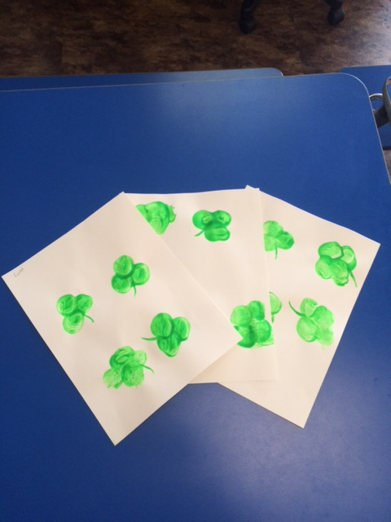Check out March artwork from Miss Sarah’s class.

CPR and Aed Certified



We at First Steps are always staying up to date with certification to make sure that your children are as safe as can be. In March, five of our hard working employees became certified in March. With the training, our employees now have the knowledge to administer CPR in times of need. The AED certification means that the employees know how to operate an automated external defibrillator The AED machine is used to combat sudden cardiac arrest by restoring normal heart rhythm. As always, we are so proud of the effort our employees put into keeping you

March Review

March was another “lucky” month. Our pal Mr. Leprechaun visited us, and he even shared some of his gold with us. Every class got to make awesome Irish art. Our school age had their spring break as well, and some of them even spent it with us. We decided to go to the library to watch the   
movie Secret Life of   
Pets. We always enjoy   
the days when we get  
to hang out with our   
school age bunch!



**EAster Plans?**

As you know, Easter is quickly approaching. We at First Steps want you to enjoy the holiday and all of the joy it brings. With that in mind, we would love to have an idea of what your plans are for the holiday weekend. If your child is going to be in the center on either Good Friday or Easter Monday, please notify us by writing your child’s name on the sign-up sheets located on Miss Geri’s desk.

EAster Bunny!

The Easter Bunny is on its way, and that means LOTS OF CANDY! As expected, First Steps will be welcoming in our furry friend once again on Thursday the 16th. We know that many of you and your children want to bring treats for classmates and teachers. This is completely acceptable, and welcomed at First Steps. However, we have a few rules to keep in mind when choosing what treats to bring.

1. No Nuts
2. No Red 40 dye
3. No liquids

Thank you for keeping these rules in mind. We cannot wait to celebrate the holiday with you and your wonderful kiddos. Happy Easter!

**April, 2017**



**Miss Lindsey**

Meet the newest member of the First Steps Team! This is Miss Lindsey. Miss Lindsey is the new transition room teacher with Miss Malory. She is quite excited to start working with your children and has lot of experience working with children. She has studied in Early Childhood Development, and has had numerous jobs in the childcare field.

Outside of work Miss Lindsey has many hobbies. One of her favorite activities is cooking/baking. She also loves to spend time watching movies and listening to music. Most importantly though, Miss Lindsey loves to spend time with her new fiancé, Tanner! Congrats on the engagement Miss Lindsey. We are very happy to have Miss Lindsey on out First Steps Team.

First Steps East  
1910 E Capitol Ave  
Bismarck, ND 58501  
(701) 258-1741  
geri@firststepsbismarck.com

**Spring is Here!**

After a snow and blizzard filled winter, we are happy that spring is upon us. With the change in season comes a change in weather and appropriate outdoor clothing. We want to make sure that every kid is properly dressed for this lovely season. That is why we have a few rules to keep in mind when dressing up your kiddos for outside play in the morning.

1. Children must have a long sleeved jacket or sweater in the morning no matter what the temperature is. As the day goes on and temperatures change, we may be able to take off our jackets.
2. Children must have pants on all day. No shorts are allowed for outside play yet.
3. Hats and gloves need to be in your child’s cubby still. We may not use them again, but the weather is never predictable. You can never outsmart Mother Nature!

Thank you in advance for helping us make sure that your children are given the opportunity to enjoy as much fun outdoor time as possible.

GOODBYE MISS CINNAMON

We are sad to announce that one of our wonderful staff members is leaving us. One of our awesome three-year-old teachers, Miss Cinnamon, is leaving. Miss Cinnamon is leaving to go back to her hometown in Washington. Miss Cinnamon is going back to be with her family, and we are happy for her. Miss Cinnamon has worked at First Steps for two years. We have enjoyed every minute of her hard work and cheerful personality. Best of luck on your new adventure Miss Cinnamon!